N-K-1 OEPriceCheck

The N-K-1 OEPriceCheck parameter is used to import the Sell Price for Orders without an Estimate Number. Many just in time manufactured items, farm out purchased boxes and packaging supplies may have an estimate number attached to the finished goods file. Therefore, there may be a valid quote attached to that estimate number in the E-Q Quote file. Advantzware has a variety of selling prices but there is a definite hierarchy. First, if the order has an estimate, then the quote file is used to import the sales prices. If the order with an estimate does not have find a quoted price, then the sell price from the I-F-1 item file will be imported. If the order does not have an estimate, the NK1 OEPriceMatrix dictates the priority. The first priority is an existing quote, then the next priority is the O-F-3 sales matrix, which has a priority sequence by customer, then customer type, then finished good item code. If a price matrix does not exist, then the program will use the N-K-1 OEPrice Check.

Logical Value = NO. When adding orders without an estimate number, the program will import sales price from either the O-F-3 price matrix or I-F-1 finished goods file. In addition, a user may override and manually type the sales price on the Order ITEMS folder.

Logical Value = YES. When adding orders without an estimate number, the software will check for estimate number on I-F-1 Item file, then search for last quoted price for that item. If the price entered on the Order Line item is different from the last quoted price a warning message will be displayed: Warning Message. "Last quoted Price = $ 9999999 Import Quoted Price? Yes will import the price. Anwser NO to keep current Price that was entered on the Order. Please note, the O-F-3 Sales Price Matrix will not be used if the Finished Goods item has an estimate and a quote exists for that estimate. If a quote does not exist, the program will search the price matrix to import a selling price. If the O-F-3 price matrix does not exist, then the sales price will import from the I-F-1 Finished Goods File.

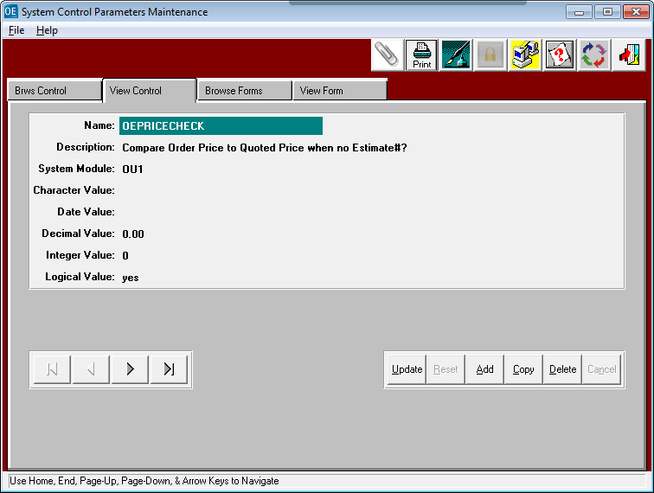

N-K-1 OEPriceCheck – Quoted Prices

When the logical value = YES, the Order Entry program will automatically search for an existing quoted price and display the matrix below. However, even if the logical value = NO, the button QUOTED PRICES will still show any quoted prices.

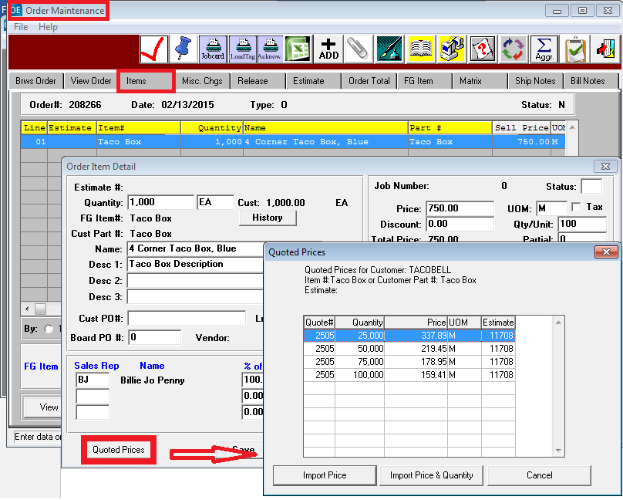

N-K-1 OEPriceCheck – Price Matrix

You can still click the MATRIX tab to see any prices associated with this finished goods item.

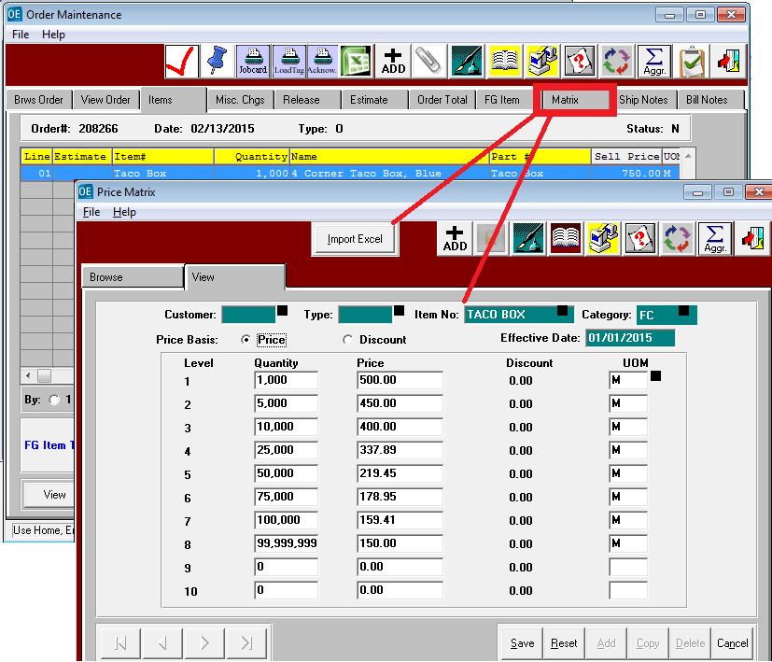

N-K-1 OEPriceCheck – Release Tab

The Sell Price on the Release tab was designed for special pricing for overruns. When defined, this will override the sales price on the ITEMS Tab. Normally, the first release would show zero price so that the ITEMS tab price will transfer to the invoice. An extra release is created for the overrun and a special price is entered. If you were shipping a release a ZERO Cost, you must set the field $0 = yes., then the sell price of $0 on the release will be transferred to the invoice.

